**Big Mountain Resort Pricing Strategy Report**

Springboard Guided Capstone Project

Author: Lori He

Date: 02.08.2023

1. **Problem Statement**

This research aims to solve the doubt about Big Mountain Resort’s current ticket price – **Based on its current facilities, what is the highest ticket price the Big Mountain Resort can increase its current price to, in order to compensate for the additional operation cost from installing a new skylift, without causing a long-term revenue drop? Is there any facility using strategies that can assist with this goal?**

* **Context**

Big Mountain Resort’s operating costs have increased due to a newly installed facility, a skylift. They would like to prevent their operating revenue from decreasing. The options they are considering include raising ticket prices and cutting costs.

* **Criteria for success and constraints**

This research should provide new operation and pricing strategies that will increase the avenue enough to compensate for the additional chair’s operation cost of $1,540,00 next year. The new strategies should guarantee the accessibility and security of all visitors. The new strategies should avoid actions that cause a continuous revenue decrease in the long term.

1. **Data Wrangling & Exploration**

The initial dataset ‘ski_data’ has 330 observations - each one representing a resort, and 27 features. The features include categorical data like ‘Region’, ‘state’, etc., and numerical data like ‘surface’, ‘trams’, etc. Duplicated resort names were observed and proved to be from different state/Region, thus the records on each row are unique.

**Cleaning and fact check**

Resort Silverton Mountain's 'SkiableTerrain_ac' data was proved to be wrong with fact check and was modified. Feature 'fastEight' doesn't have enough data to be useful and thus was dropped. Feature 'yearsOpen' has one unreasonable data ('2019') and the row containing it was dropped. Rows with no price data for either weekday or weekend were dropped. As the ticket prices on weekdays and weekends are close to each other, the feature 'AdultWeekday' which has more missing data was dropped. Rows that have missing data in 'AdultWeekend' were also dropped. By dividing some of the features by state population, 7 new features were created.

After cleaning and fact check, the new dataset had 277 rows and 35 columns. The target feature was assigned to be 'AdultWeekend' (ticket price on weekends).

**Observation**

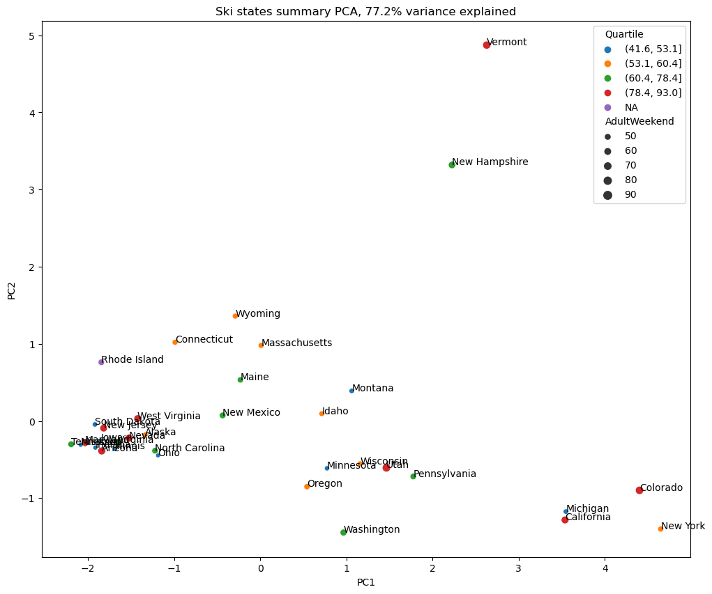

Fig 1. Distribution of states’ correlation with first two PCA components.

Fitting the dataset with PCA transformation resulted in two components that account for 75% of the variance. A distribution plot (Fig 1) of the two components showed that Vermont and New Hampshire were under certain features’ influence much more than other states. Those features were revealed to be ‘resorts_per_100ksq_mile’ and ‘resorts_per_100kcapita’ with further analysis.

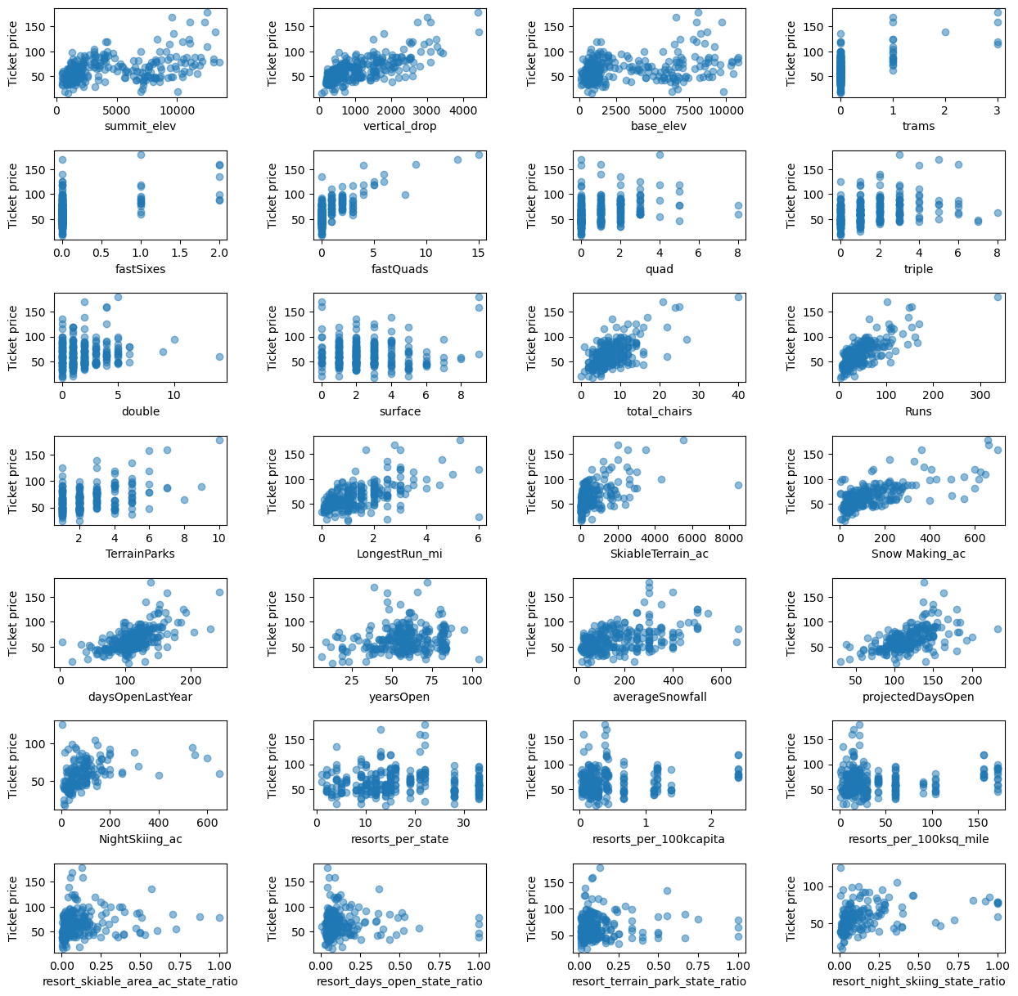

Fig 2. Correlations between ticket price and selected 28 features.

The scatterplots (Fig 2) revealed high correlations between the ticket price and features such as ‘vertical_drop’, ‘fastQuads’, ‘Runs’, and ‘total_chairs.

1. **Training and Modeling**

The dataset was split into a training set (70%) and a test set(30%) and trained on three models: Dummy Model, Linear Regression, and Random Forest. Cross-validation and GridSearchCV were used to evaluate training results from each model. The random forest model was selected as the best model, with the lowest mean absolute error.

All the data were trained on the selected model. The final cross-validation score had a mean of 10.39 and an std of 1.47.

The selected model predicted the most reasonable ticket price, based on its facility features, to be $95.87, with a mean absolute error of $10.39. This suggested that there is reasonable room for Big Mountain Resort's ticker price to increase.

1. **Conclusion**

Assuming that all other resorts are largely setting prices based on how much people value certain facilities and that prices are set by a free market, our model suggested that there is room to increase the ticket price of Big Mountain Resort. The new price can range from $85.48 (most conservative) to $95.87 (most aggressive). Assuming the number of total visitors doesn't change, with the conservative strategy, the annual revenue will increase by $5204297; with the aggressive strategy, the annual revenue will increase by $1566696. Both can compensate for the additional operating cost of the new chair lift.